**MINOR PROJECT REPORT**

**On**

**SWITCHING SYSTEM FOR COMPUTER LABS B.Tech**

**in**

**COMPUTER SCIENCE & ENGINEERING**

**Submitted By**

**MAYANK JATAV, AMAN VERMA, JATIN CHAWLA**

**Roll. No:**

**0208CS171060, 0208CS171009, 0208CS171053**



**DEPTT. OF COMPUTER SCIENCE & ENGINEERING**

**Gyan Ganga College of Technology**

**Jabalpur, Madhya Pradesh**

**Mar  2020**

**PREFACE**

**Minor Project is an integral part of B.Tech and each and every student has to create the Minor Project in the 6th Semester while studying in Institute.**

**This record is concerned about our practical Minor Project during 6th Semester i.e. pre final year of B.Tech. course. We have taken our Practical Minor Project in “SWITCHING SYSTEM FOR COMPUTER LABS”. During this Minor Project, we got to learn many new things about the technology and its practical implementation. This Minor Project proved to be a milestone in our knowledge of present environment. Every say and every moment was an experience in itself, an experience which theoretical study can’t provide.**

**ACKNOWLEDGEMENT**

**It is our pleasure to be indebted to various people, who directly or indirectly contributed in the development of this work and who influenced our thinking, behavior and acts during the course of study.**

**We express our sincere gratitude to *Dr. Neeraj Shukla* worthy Principal for providing us an opportunity to undergo Minor Project in “SWITCHING SYSTEM FOR COMPUTER LABS”**

**We are thankful to *Prof. Saurabh Sharma* for his support, cooperation, and motivation provided to us during the Minor Project for constant inspiration, presence and blessings.**

**We also extend my sincere appreciation to *Prof. Sandeep Rao,* who provided his valuable suggestions and precious time in accomplishing my Minor Project  report.**

**Lastly, we would like to thank the almighty and our parents for their moral support and our friends with whom we shared our day-to day experience and received lots of suggestions that my quality of work.**

**Mayank Jatav,**

**Aman Verma,**

**Jatin Chawla.**

**DECLARATION**

**We, MAYANK JATAV, AMAN VERMA, JATIN CHAWLA. Roll No. 0208CS171060, 0208CS171009, 0208CS171053, , B.Tech (Semester- VI) of the Gyan Ganga College of Technology, Jabalpur hereby declare that the Minor Project Report entitled “SWITCHING SYSTEM FOR COMPUTER LABS” is an original work and data provided in the study is authentic to the best of my knowledge. This report has not been submitted to any other Institute for the award of any other degree.**

**Mayank Jatav, Aman Verma, Jatin Chawla.**

**(Roll No. 0208CS171060,0208CS171009, 0208CS171053)**

**Place: Gyan Ganga College Of Technology**

**Date: March 2020.**

**This is to certify that above statement made by the candidates is correct to the best of our knowledge.**

**Approved by:**

|  |  |  |
| --- | --- | --- |
| **Prof. Saurabh Sharma,**  **Project Coordinator,**  **Assitant Professor,**  **Department of CSE,**  **GGCT,JABALPUR** | **Prof.Sandeep Rao,**  **Assitant Professor,**  **Department of CSE,**  **GGCT,JABALPUR** | **Dr. Ajay Lala,**  **Hod (CSE),**  **Department of CSE,**  **GGCT,JABALPUR** |

**GYAN GANGA COLLEGE OF TECHNOLOGY**

**JABALPUR (MP)**



**Approved by AICTE New Delhi & Govt. of M.P.**

**(Affiliated to Rajiv Gandhi Proudyogiki Vishwavidhyalaya, Bhopal)**

**Certificate**

**This is to certify that the Minor Project report entitled “Switching System For Computer Labs” is submitted by Mayank Jatav, Aman Verma ,Harsh Swaroop Singh, Jatin Chawla, Khushboo Kumari and Ayushi Mahule ,for the partial fulfillment of the requirement for the award of degree of Bachelor of Engineering in Department of Computer Science & Engineering from Rajiv Gandhi Proudyogiki Vishwavidyalaya, Bhopal (M.P).**

**(Internal Examiner) (External Examiner)**

**Abstract**

**This project “SWITCHING SYSTEM FOR COMPUTER LABS”, basically is an idea of switching on and off computer labs through mobile phone connected to the same network. This project is made as a helping hand to all the lab attendants working in a organisation. With the help of this project , the lab attendants will be able to control basic functionalities of the lab like ‘Shutting down’ all the computers in a single click, ‘switching’ on and off the switches in the computer lab, etc. With the help of this project, the overhead of shutting down all the computers in the lab manually , will be solved and this will be a sigh of relief to the lab attendants.**

**List of figures**

|  |  |
| --- | --- |
|  | * **Fig 1:** Overview Diagram * **Fig 2:** ESP8266(NodeMCU) * **Fig 3:** 5V 4-Channel Relay Module * **Fig 4:** Jumper wires * **Fig 5:** Breadboard * **Fig 6:** Android Studio Welcome screen * **Fig 7:** Arduino IDE * **Fig 8:**Use Case * **Fig 9:**Use Case * **Fig 10:**Use Case * **Fig 11:**Use Case * **Fig 12:** DFD 0 * **Fig 13:** DFD 1 * **Fig 14:** DFD 2 * **Fig 15:** Login Screen * **Fig 16:** Operations Screen * **Fig 17:** Configure labs Screen * **Fig 18:**Add System Screen * **Fig 19:**Operate Labs Screen * **Fig 20:**Operate System Screen * **Fig 21:** Operate Switches screen |
|  |

**Timeline**

Estimated project duration 4 Months

1 ANALYSIS : Four weeks.

2 DESIGN : Five weeks.

3 CODING : Four weeks.

4 TESTING : Four weeks.

**Table of Contents**

|  |  |  |  |
| --- | --- | --- | --- |
| **Title Page**  **Preface**  **Acknowledgement** | | **i**  **ii**  **iii** | |
| **Declaration of the Student** | | **iv** | |
| **Certificate of the Guide** | | **v** | |
| **Abstract** | | **vi** | |
| **List of Figures** | | **vii** | |
|  | |  | |
| **Timeline** | | **viii** | |
| **1.** | **INTRODUCTION\*** | | **1** | |
|  | * **Problem Definition** * **Project Overview/Specifications* (page-1 and 3)** * **Hardware Specification** * **Software Specification**   **1.3.1**  **1.3.2**  **…** | | **1**  **2**  **3**  **4**  **4** | |
|  |  | |  | |
| **2.** | **LITERATURE SURVEY** | | **5** | |
|  | **2.1 Existing System**  **2.2 Proposed System**  **2.3 Feasibility Study* (page-4)** | | **5**  **6**  **7** | |
|  |  | |  | |
| **3.** | **SYSTEM ANALYSIS & DESIGN** | |  | |
|  | **3.1 Requirement Specification* (page-2)**  **3.2 Use Case Diagrams**  **3.3 Data Flow Diagrams**  **3.4 Algorithms and Pseudo Code**  **3.5 Testing Steps/Criteria** | | **9**  **10**  **12**  **16**  **18**  **19**  **22**  **27** | |
|  |  | |  | |
| **4.** | **RESULTS / OUTPUTS** | | **40** | |
| **5.** | **CONCLUSIONS / RECOMMENDATIONS** | | **47** | |
| **6.** | **REFERENCES** | | **49** | |
| **7.** | **APPENDICES** | | **50** | |
|  |  | |  | |

* **Introduction**

In present scenario, in our computer Labs, all the computers are connected to each other in such a way so that they can access shared resources such as files, system resources and printers etc.

The major drawback of the existing system is, there is no centralized management of the resources unlike the domain network. Due this drawback, the lab attendants were facing a lot of problems in manually shutting down each and every system. It’s a very time consuming process, and wastes a lot of time in doing such a task.

And here we got the Idea!

We thought what if we can shut down all the systems, in a single click from a mobile application.

* **Problem definition**

In our college, the computer labs are connected in such a way that all participating and connected systems to access shared resources such as files, system resources and printers.

This type of setup is best suited for small networks of no more than ten computers. In this setup there is no centralised server or database. Each computer is equal to all of the others and can share resources with the others. However, this sharing of resources must be set up on a machine per machine basis. All machines connected on the same network will be able to share resources within that network.

Since, in this setup there is no centralised server or database, there is no such point from which all the computers can be controlled and can be set to particular command on a single click.

Due to this problem, the lab attendants, face a lot of problems and need to do some extra work. They, need to do all basic functions like ‘shutting down’ or ‘setting the computer on the sleep mode’, etc. , manually. As, ‘shutting down’ each and every computer in a lab is a long and time consuming process. The precious time of the lab attendants gets wasted in doing such a worthless task.

Lab attendants have many other works too, which are important than this task, i.e. ‘shutting down’ all the computers one after the others. Its , simply a wastage of time, which can be utilised in doing other productive tasks.

Moreover, lab attendants also need to turn the switches ON and OFF manually for each lab after shutting down all the computers.

Hence, the above problems reduce the work efficiency of the lab attendants, this problem is needed to be solved and make things easy for them.

So, this was the problem definition and the solution to this problem is given in the next following chapters.

* **Project Overview/Specifications**

When we noticed, the above stated problem and analysed that how important is it to overcome this problem, as existing system results in huge amount of time wastage, then we thought being an engineer or would be engineer, its our duty to solve this problem and make things easier and fast for the lab attendants. Then, suddenly a thought came, that what if all the switching operations of the labs can be done with the help of just few clicks on a mobile application. And that’s how we decided to build a mobile based application, to control the switching operations of the labs.

In this project, we are making a **smarter, convenient and faster** switching system for computer labs. Our project can be explained in short by this phrase- “Switching computer labs through Smart phones”.

As mentioned in above parts, existing system in the labs is too **time consuming.** This system needs to be changed in order to save the precious time of lab attendants and make things easy for them. And nowadays, the best way of making things easier and fast, is just converting a set of existing operations into a mobile application. As nowadays mobile phone is not only a communication tool but also a powerful weapon to do a lot of things related to hardware. As in today’s world a ‘smartphone’ is very common thing that everybody have and can easily operate it too.

So, here is an overview that what we are actually doing.

First of all we need all the computer of the labs to be connected to the same network. So, that the computers can communicate with each other. A file coded in language ‘C’ will be installed on each computer in the network so that the computers will be able to read the instructions sent by us and act accordingly. One of the computers in the network will be made as the master computer, where will store our data like login credentials, commands for the computers etc.

This master computer will be in contact with our smartphone. Smartphone and the master computer will be connected to the same network in which all the computers are connected , this wireless connection will be made through an IOT device known as ‘Node MCU’.

We will connect a **smart phone** to the network, in which all the **computers** are connected. Then we will send a message to the server from our application, which will send commands like **shutdown, sleep** etc. to all the computers connected in the network.

Moreover, with the help of an **IOT device**, a signal will be sent to **turn** **OFF/ON** the **power** of the lab and various switches of the lab.

**Diagrammatic Overview of the project**

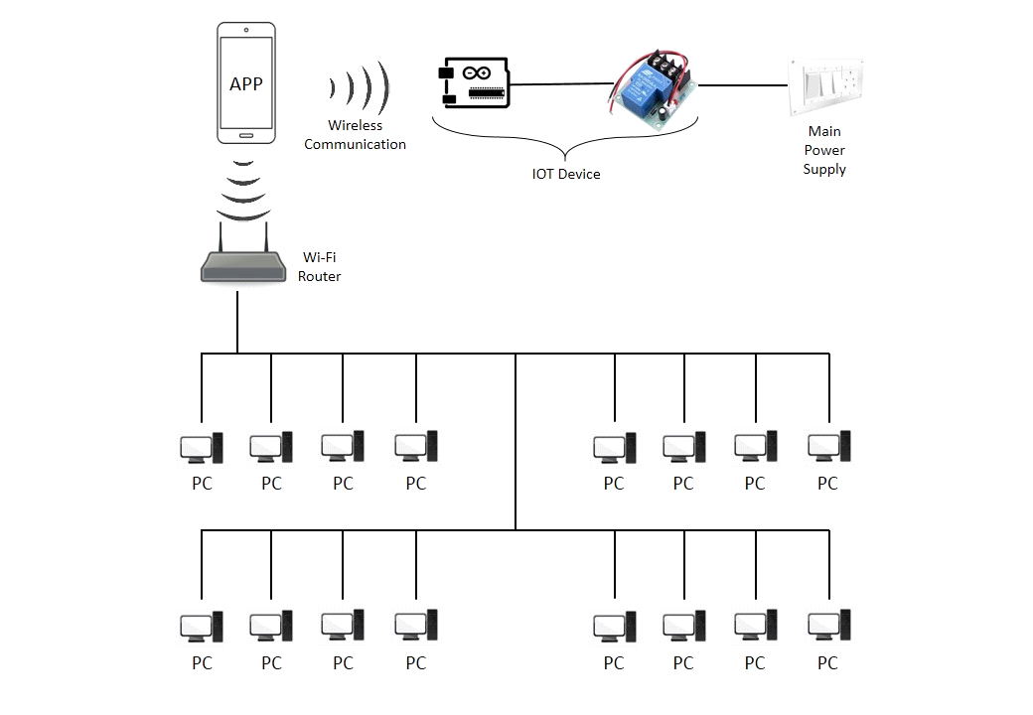

Fig.1 Overview Diagram

* **Hardware Specification**

Hardware specification tells us about the hardware requirement, that is to be used in completion of the project and hardware required so that the project can be deployed easily and work properly.

* **NodeMCU(ESP8266)**

**NodeMCU** is an open source IoT platform. It includes [firmware](https://en.wikipedia.org/wiki/Firmware) which runs on the [ESP8266](https://en.wikipedia.org/wiki/ESP8266) [Wi-Fi](https://en.wikipedia.org/wiki/Wi-Fi) SoC from Espressif Systems, and hardware which is based on the ESP-12 module.The term "NodeMCU" by default refers to the firmware rather than the development kits.

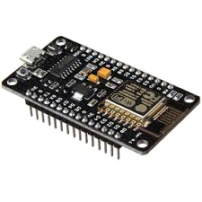

Fig 2. ESP8266(NodeMCU)

Cost: Rs. 265

* **5v 4-Channel Relay Module**

A **relay** is an electrically operated switch that can be turned on or off, letting the current go through or not, and can be controlled with low voltages, like the 5V provided by the Arduino pins.  
This is a 5V 4-channel relay interface board, and each channel needs a 15-20mA driver current. It can be used to control various appliances and equipment with large current. It is equipped with high-current relays that work under AC250V 10A or DC30V 10A. It has a standard interface that can be controlled directly by microcontroller.

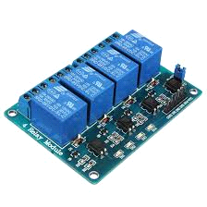  
Fig 3. 5V 4-Channel Relay Module

Cost: Rs. 155

* **Jumper Wires**

**Jumper wires** are simply **wires** that have connector pins at each end, allowing them to be used to connect two points to each other without soldering. **Jumper wires** are typically used with breadboards and other prototyping tools in order to make it easy to change a circuit as needed

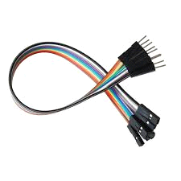  
Fig 4. Jumper wires

* **Breadboard**

A **breadboard** is a solderless device for temporary prototype with electronics and test circuit designs. Most electronic components in electronic circuits can be interconnected by inserting their leads or terminals into the holes and then making connections through wires where appropriate.

A **breadboard** is **used to** build and test circuits quickly before finalizing any circuit design. The **breadboard** has many holes into which circuit components like ICs and resistors can be inserted.

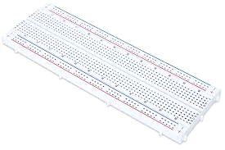

Fig 5.Breadboard

Cost: Rs. 65

**For the smooth and proper working of the project, all the computers must be connected in the same network. And Operating System of the mobile phone must be greater than Android 4.2.**

* **Software Specification**

This part of the document, specifies the software which are required in the development of the project and the software which is required to be present in each project as a basic need.

**1.4.1 Android Studio 3.5.1**

**Android Studio** is the official[[7]](https://en.wikipedia.org/wiki/Android_Studio) [integrated development environment](https://en.wikipedia.org/wiki/Integrated_development_environment) (IDE) for [Google](https://en.wikipedia.org/wiki/Google)'s [Android](https://en.wikipedia.org/wiki/Android_(operating_system)) [operating system](https://en.wikipedia.org/wiki/Operating_system), built on JetBrains' IntelliJ IDEA software and designed specifically for [Android development](https://en.wikipedia.org/wiki/Android_software_development).[[8]](https://en.wikipedia.org/wiki/Android_Studio) It is available for download on [Windows](https://en.wikipedia.org/wiki/Windows), macOS and [Linux](https://en.wikipedia.org/wiki/Linux) based operating systems.[[9][10]](https://en.wikipedia.org/wiki/Android_Studio) It is a replacement for the [Eclipse Android Development Tools](https://en.wikipedia.org/wiki/Eclipse_(software)) (ADT) as the primary IDE for native Android application development.

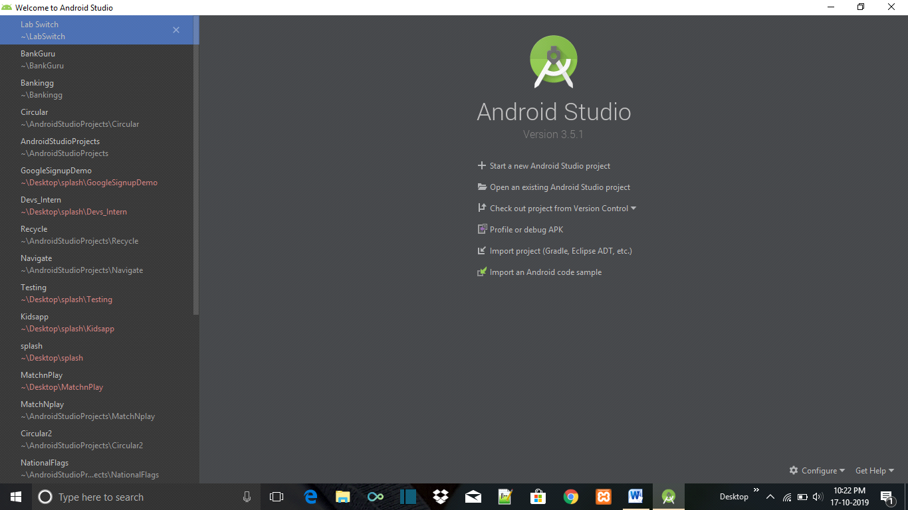

Fig 6.Android Studio Welcome screen

**1.4.2 Arduino IDE 1.8.7**

The **Arduino integrated development environment (**[**IDE**](https://en.wikipedia.org/wiki/Integrated_development_environment)**)** is a [cross-platform](https://en.wikipedia.org/wiki/Cross-platform) application (for [Windows](https://en.wikipedia.org/wiki/Windows), macOS, [Linux](https://en.wikipedia.org/wiki/Linux)) that is written in the programming language [Java](https://en.wikipedia.org/wiki/Java_(programming_language)). It is used to write and upload programs to Arduino compatible boards, but also, with the help of 3rd party cores, other vendor development boards.

The source code for the IDE is released under the [GNU General Public License](https://en.wikipedia.org/wiki/GNU_General_Public_License), version 2. The Arduino IDE supports the languages [C](https://en.wikipedia.org/wiki/C_(programming_language)) and [C++](https://en.wikipedia.org/wiki/C%2B%2B) using special rules of code structuring. The Arduino IDE supplies a [software library](https://en.wikipedia.org/wiki/Software_library) from the [Wiring](https://en.wikipedia.org/wiki/Wiring_(development_platform)) project, which provides many common input and output procedures. User-written code only requires two basic functions, for starting the sketch and the main program loop, that are compiled and linked with a program stub *main()* into an executable [cyclic executive](https://en.wikipedia.org/wiki/Cyclic_executive) program with the [GNU toolchain](https://en.wikipedia.org/wiki/GNU_toolchain), also included with the IDE distribution. The Arduino IDE employs the program *avrdude* to convert the executable code into a text file in hexadecimal encoding that is loaded into the Arduino board by a loader program in the board's firmware.

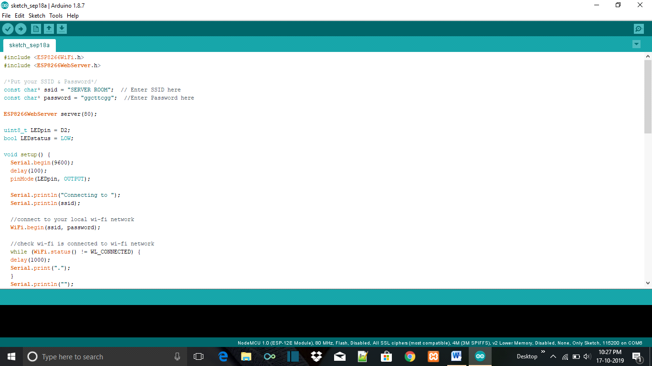

Fig 7.Arduino IDE

**1.4.3 Receiver program**

This program is written in C language and is required to be installed in each and every computer in the network. The program will be responsible for reading the commands and making the computer to act accordingly.

**1.4.4 Sender program**

This program is written in C language and is required to be installed in the master computer of the network. The program will be responsible for sending the commands to other computers of the network .

**2. Literature Survey**

The **purpose** of a **literature review** is to gain an understanding of the existing research and debates relevant to a particular topic or area of study, and to present that knowledge in the form of a written report. Conducting a **literature review** helps you build your knowledge in your field.

A **literature review** is a search and evaluation of the available literature in ... It documents the state of the art with respect to the subject or topic **you are** writing about. ... and that **you understand** where your own research fits into and adds to an ...

**2.1 Existing system**

In case of this project, best way to study and do the survey of existing system, was to go to the our college’s lab and go learn and study about the current working of the labs and the computers connected on the networks. We completed a deep study on how our labs work together and how the computers are connected to each other and the network.

So, we daily went to the labs for a week and conducted meetings with different lab attendants, and gathered information about how these labs actually work.

After a deep study we have concluded a synopsis about the main information we got about the current working of labs. The conclusion of the survey is as follows:

* In our college, the computer labs are connected in such a way that all participating and connected systems to access shared resources such as files, system resources and printers.
* This type of setup is best suited for small networks of no more than ten computers.
* In this setup there is no centralized server or database.
* Each computer is equal to all of the others and can share resources with the others. However, this sharing of resources must be set up on a machine per machine basis.
* All machines connected on the same network will be able to share resources within that network.
* As, in this setup there is no centralized server or database, there is no such point from which all the computers can be controlled and can be set to particular command on a single click.
* And even if it is made possible to control other computers through any one of the computers present in the network, it will not be possible to give command to only selected computers.
* Due to this problem, the lab attendants, face a lot of problems and need to do some extra work. They, need to do all basic functions like ‘shutting down’ or ‘setting the computer on the sleep mode’, etc. , manually.
* As, ‘shutting down’ each and every computer in a lab is a long and time consuming process. The precious time of the lab attendants gets wasted in doing such a worthless task.

So, that’s how the existing system in our college labs was working and as above mentioned problem needs to be solved and we found a gap in the existing system and we are going to solve this problem.

**2.2 Proposed system**

In order to solve the problem of the existing system, we can simply say that, “How easy it would be, if we could control the switching the systems of labs and switching operations of the computers present in the labs, with the help of a smartphone”.

In this project, we are making a **smarter, convenient and faster** switching system for computer labs. Our project can be explained in short by this phrase- “Switching of computer labs through Smart phones”.

As mentioned, the existing system is very time consuming and in today’s world ‘time is money’. So, we are saving the time of lab attendants, by bringing a smarter and faster way to shut down a PC or more than one PC’s connected in a LAN.

So, how will we do that?

First of all we need all the computer of the labs to be connected to the same network. So, that the computers can communicate with each other. A file coded in language ‘C’ will be installed on each computer in the network so that the computers will be able to read the instructions sent by us and act accordingly. One of the computers in the network will be made as the master computer, where will store our data like login credentials, commands for the computers etc.

This master computer will be in contact with our smartphone. Smartphone and the master computer will be connected to the same network in which all the computers are connected , this wireless connection will be made through an IOT device known as ‘Node MCU’.

We will connect a **smart phone** to the network, in which all the **computers** are connected. Then we will send a message to the server from our application, which will send commands like **shutdown, sleep** etc. to all the computers connected in the network.

Moreover, with the help of an **IOT device**, a signal will be sent to **turn** **OFF/ON** the **power** of the lab and various switches of the lab.

So, this was the system proposed by us, which will help in saving the time of the lab attendants. So, now they will be able to do the tasks which are more important rather than wasting time in manually shutting sown each and every system.

**2.3 Feasibility study**

As the name implies, a **feasibility analysis** is used to determine the viability of an idea, such as ensuring a **project** is legally and technically **feasible** as well as economically justifiable. It tells us whether a **project** is worth the investment—in some cases, a **project** may not be doable.

**2.3.1 Legal feasibility**

Our project is made for small labs and currently specific for our college’s labs. Since, this project belongs to our college labs and we are permitted for further working on this project, our project is legally feasible. We have used all the open source software. Everything which is documented and implemented is solely made/created by us and no one can claim for copyrights. Thus, our project is completely feasible.

**2.3.2 Technical feasibility**

Our project is technically feasible, as we know that any functionality in a PC can be done with the help of ‘Command Prompt’. Thus, we just need to send a signal to the PC to perform a certain task. We can a signal to the PC with the help of IOT devices like Arduino UNO and NodeMCU . As we need wireless communication between mobile phone and and PC , we chose NodeMCU as our communicating medium. As we can communicate between one phone and one computer we can also communicate with more than one computer connected to the same network.

Thus , a mobile application can be made to send and receive commands to and from a PC or group of PCs connected in the same network.

That’s this project is technically feasible.

**2.3.3 Economic feasibility**

The cost of our complete project is not more than Rs.800 for one lab including hardware and software cost. For a big organisation like our college its not a big amount and its very economic. It is a one time investment. A common lab system and a common network is already present in the college and we just need to buy some inexpensive IOT devices , which are easily and cheaply available in the market .That’s how our project is economically feasible.So, this was the feasibility study of this project , now let’s move towards the design part.

* **System Analysis and Design**

[System analysis](https://en.wikipedia.org/wiki/Systems_analysis)**, a method of studying a system by examining its component parts and their interactions.**

**System design contains diagrams which gives us the details about the implementation of the project.**

* **Requirement Specification**

Since, this is a very small scale project, specifically made for our college’s computer labs, we do not need high requirements or costly requirements. We just have a very cheap and short requirements list.

* All the computers must be connected to the same network and the mobile phone containing our application must also be connected to the same network.
* Operating system of the target computers must have Windows 8.1 operating system or above versions of windows operating system.
* Operating system of the smart phone which will carry our application must contain Android operating system, version android 4.2 (Jelly Bean).
* All the target computers, must contain a **receiver file**, which is created by us in .C .This receiver file is written in C language. This file is made for reading the commands sent from the master computer. This file reads the commands and commands to target computer to accordingly.
* Master computer, must contain **sender file,** which is created by us. This file is written in C language. This file is made to send the signals to the receiver/target computers. This file receives signals from the mobile phone.
* The computer which is made as master computer must be secure, should only be accessed by authorized people.
* The application will work only when the phone is connected to the network

Thus, these were the requirement specification for this project.

* **Use Case Diagrams**

**3.2.1 Whole System**

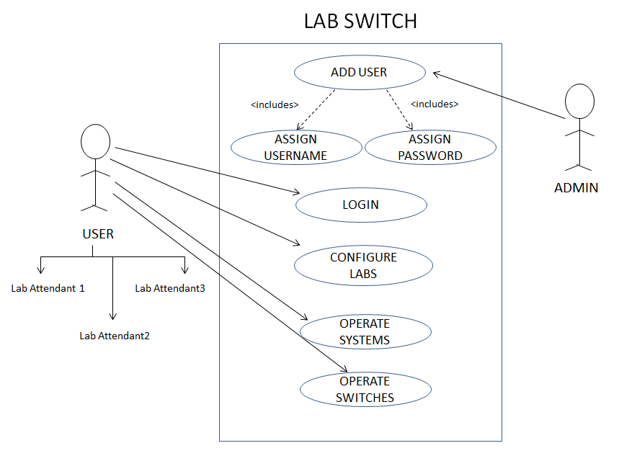

Fig 8.Use Case

**3.2.2 Subsystem(Configure Labs)**

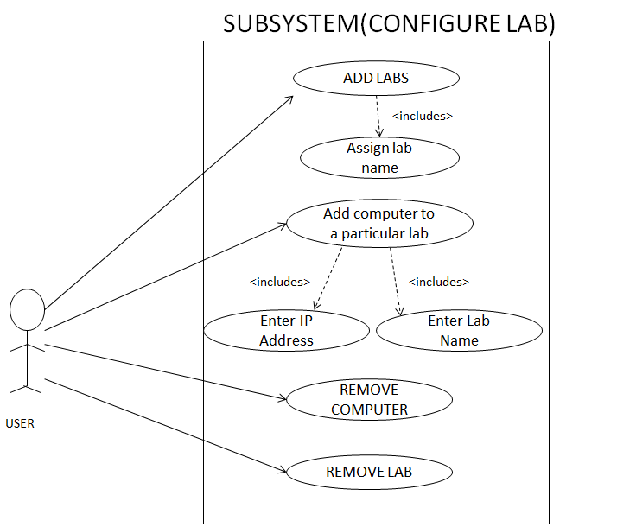

Fig 9.Use case

**3.2.3 Subsystem(Operate System)**

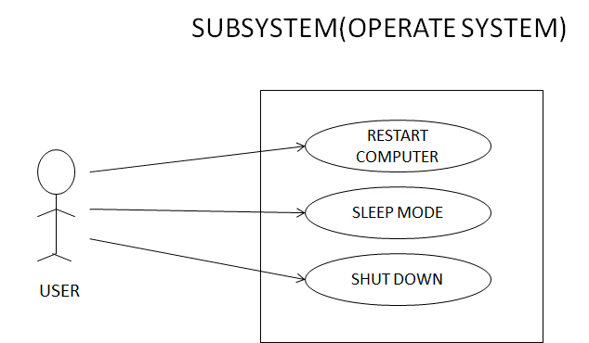

Fig 10.Use Case

* **Subsystem(Operate Switches)**

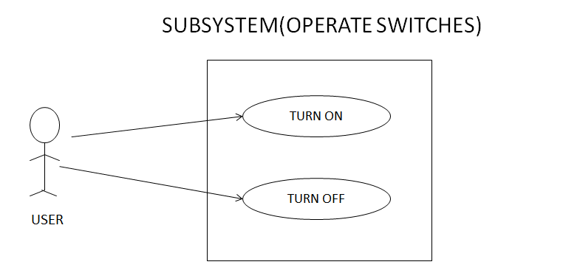

Fig 11.Use Case

* **Data flow Diagrams**

**3.3.1 level-0 DFD**

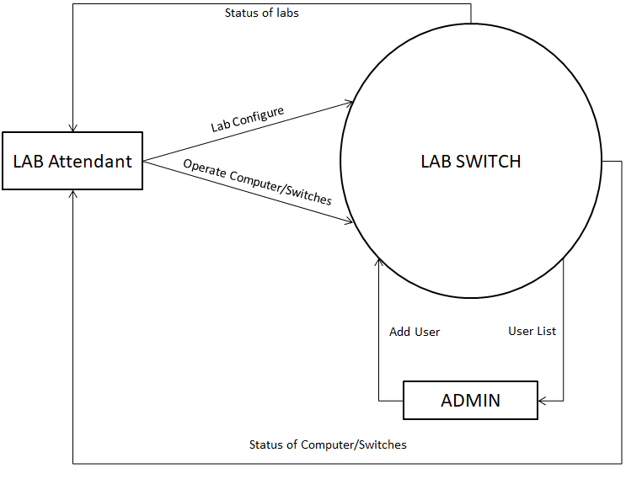

Fig 12.DFD 0

**3.3.2 level-1 DFD**

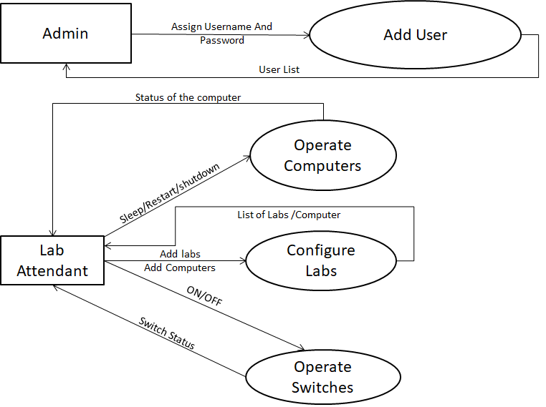

Fig 13.DFD 1

* **level-2 DFD**

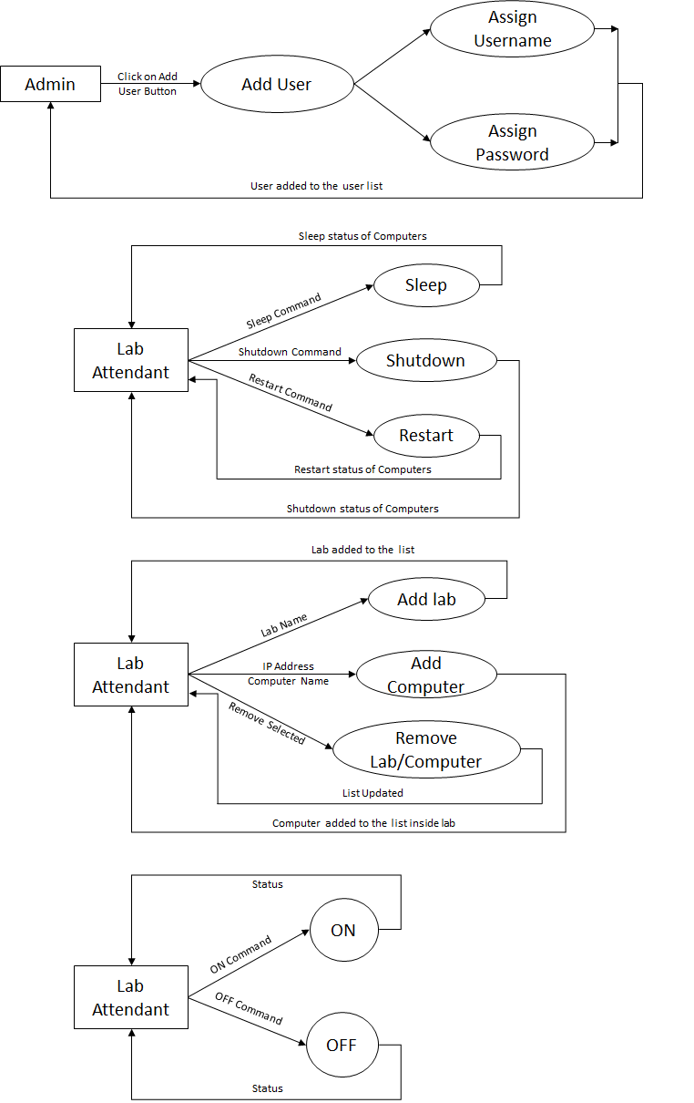

Fig 14.DFD 2

**3.4 Algorithms and Pseudo codes**

**3.4.1 Configure Lab**

Algorithm Add Labs

Step:1 Click on Add Labs Button.

Step:2 Enter the name of the lab.

Step:3 Click on OK button.

Algorithm Add Computer

Step:1 Click on Add Computer Button.

Step:2 Enter the IP Address of the target PC.

Step:3 Enter the PC name of the target PC according to the user’s convenience.

Step:4 Click on OK button.

Algorithm Delete Computer

Step:1 Click on Delete option.

Step:2 Select the PC to be deleted.

Step:3 Click on delete button.

Step:4 Confirm deletion.

Algorithm Delete Lab

Step:1 Click on Delete option.

Step:2 Select the Lab to be deleted.

Step:3 Click on delete button.

Step:4 Confirm deletion.

**3.4.2** **Operate System**

Restart system

Step:1 Select PCs form the list.

Step:2 Click the Options button.

Step:3 Select the restart option.

Step:4 Click OK.

Sleep mode

Step:1 Select PCs form the list.

Step:2 Click the Options button.

Step:3 Select the sleep option.

Step:4 Click OK.

Shut Down

Step:1 Select PCs form the list.

Step:2 Click the Options button.

Step:3 Select the shut down option.

Step:4 Click OK.

**3.4.3 Operate Switches**

Turn ON

Step:1 Click the options button

Step:2 Click the Switch ON option.

Step:3 Confirm Switch ON.

Turn OFF

Step:1 Click the options button

Step:2 Click the Switch OFF option.

Step:3 Confirm Switch OFF.

**3.5 Testing Steps/Criteria**

* **Testing of the connections, between devices and instruments:** Any connection failure between the IOT devices or Computers in the network or mobile phone, will result in the failure of the project.
* **Testing of proper communication between the parts of the project:** To test the communication between the Smartphone and NodeMCU via WIFI.

To check the communication between, NodeMCU and Master computer.

To check the communication between Master computer and all other computers connected in the network.

* **Testing of proper sync between the Graphical User Interface and actual working:** GUI should match the timing of working of hardware of the project for the greater user experience.
* **Testing of proper feedback signals from hardware devices to Application:** After performing the specified operation, the devices must give a feedback signal to the application. This, will help in the acknowledge the users that the specified task is accomplished.
* **Final Testing of all the operations that the application is supposed to do:** Keeping all the parts of the project together and finally testing of the proper working of the project .

After completing all the above steps, final testing of the project will be completed and the project will be ready to be implemented.

* **RESULTS / OUTPUTS**
* **Login Screen**

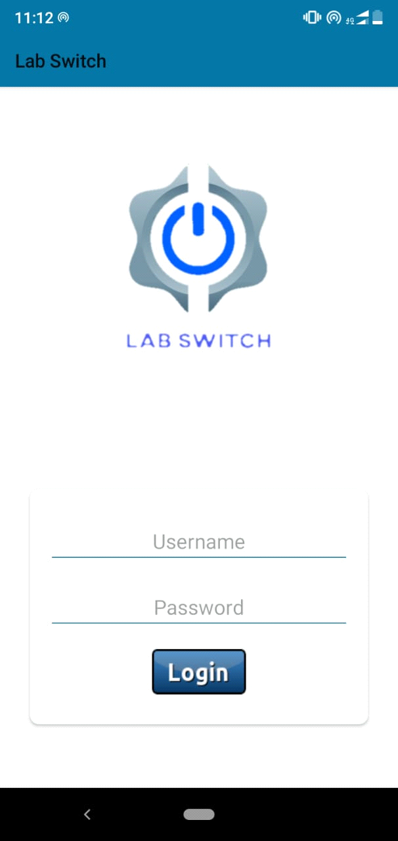

Fig 15.Login Screen

With the help of this login screen, the user(lab attendants ) can login to the application and control the labs, through the smart phone.

* **Operations Screen**

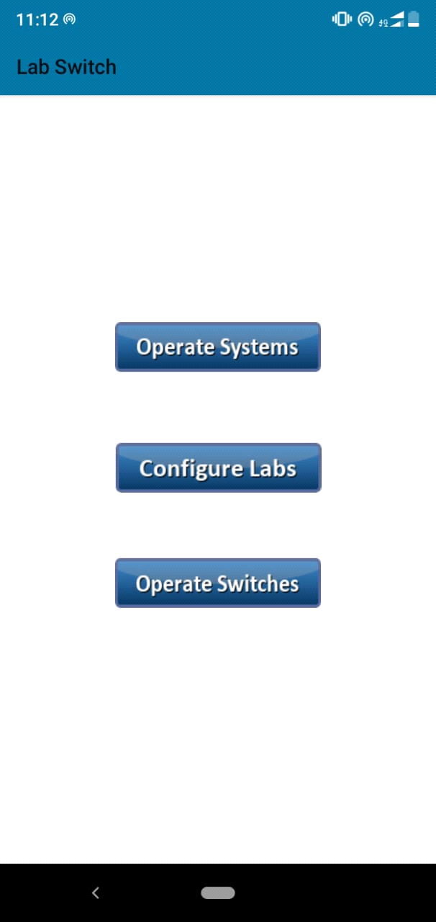

Fig 16.Operations Screen

This operation screen contains 3 buttons.

* Operate Systems
* Configure Labs
* Operate Switches

On clicking ‘configure labs’, the user will be directed to the configure labs panel. Here, the users can add/ remove labs and add/remove computers to a particular lab.

On clicking ‘Operate Systems’, the user will be directed to the operate system panel. Here, user can send the *shutdown, restart or sleep* command.

On clicking ‘Operate Switches’, the user will be directed to operate switches panel. Here, the physical electric switches can be operated.

* **‘Configure labs’ Screen**

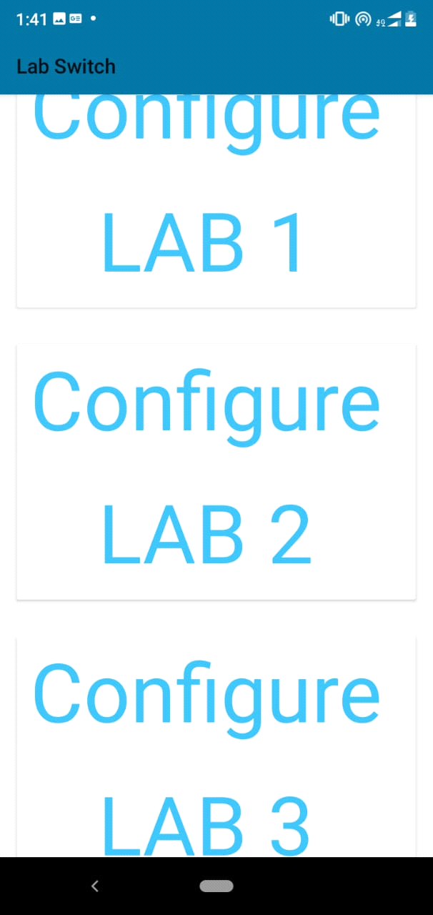

Fig 17.Configure labs Screen

This screen shows a scrolling list of the added labs on the application. On long press for any lab, this lab can be removed from the application. On clicking on any of the lab, the user is redirected to the add system panel, where user can add or remove the system.

* **Add Systems Screen**

This screen shows the list of all the system that are added to the current lab.

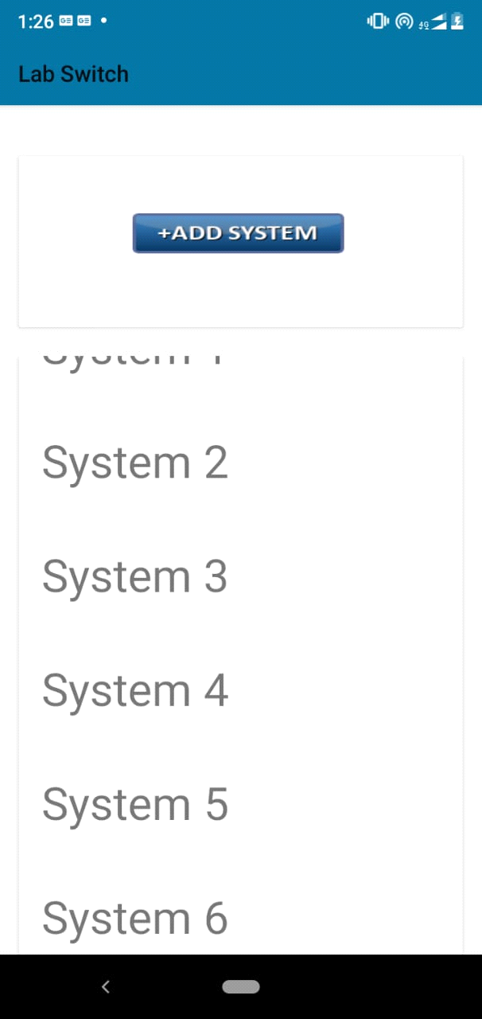 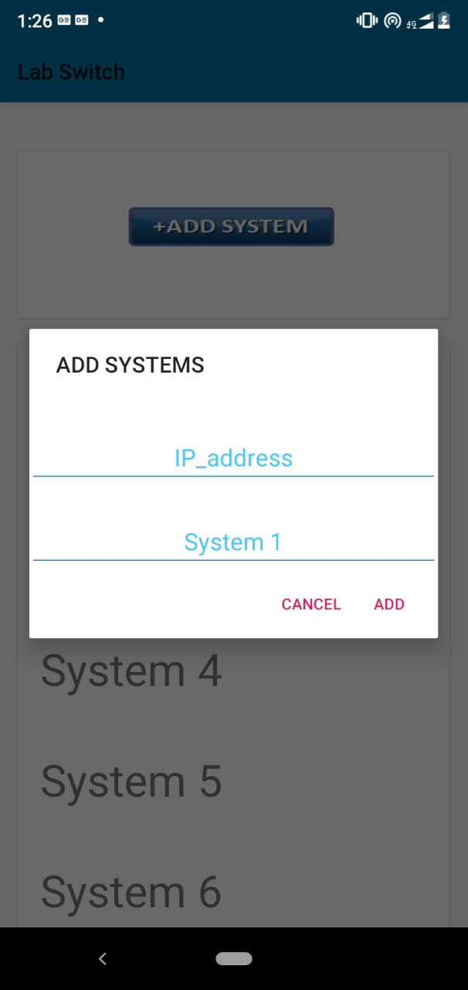

Fig 18.Add System Screen

On clicking the ‘add system’ button, a dialog box drops and takes two inputs i.e. system IP address and System name. Then, after clicking the add button, the system name will be added to the list.

* ‘**Operate Labs’ Screen**

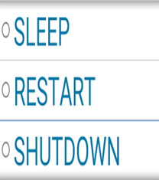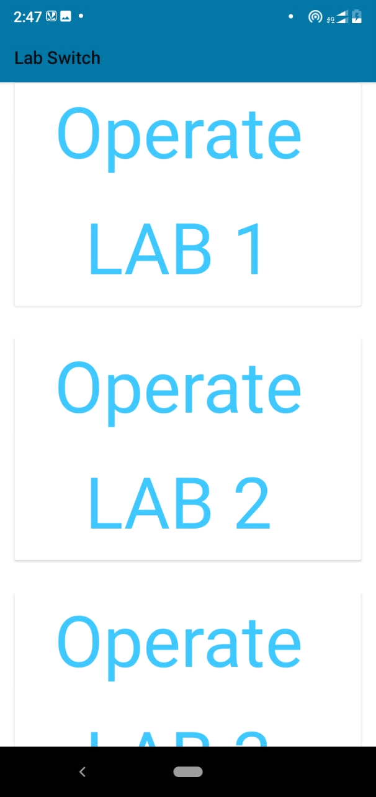

Fig 19.Operate labs Screen

This screen shows the, scrolling blocks of different labs. On long Press a drop down menu appears containing *sleep , restart* and *shutdown.* On clicking one of the options, the command will be transferred to all the computers assigned to that lab. On hitting one of the block user can enter the system operations of the corresponding lab.

* ‘**Operate Systems’ Screen**

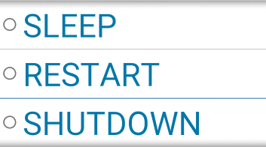

Fig 20.Operate Systems Screen

This screen shows the, scrolling list of different labs. On long Press a drop down menu appears containing *sleep, restart* and *shutdown.* On clicking one of the options, the command will be sent to the target system assigned to that lab.

* ‘**Operate Switches’ Screen**

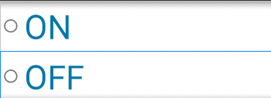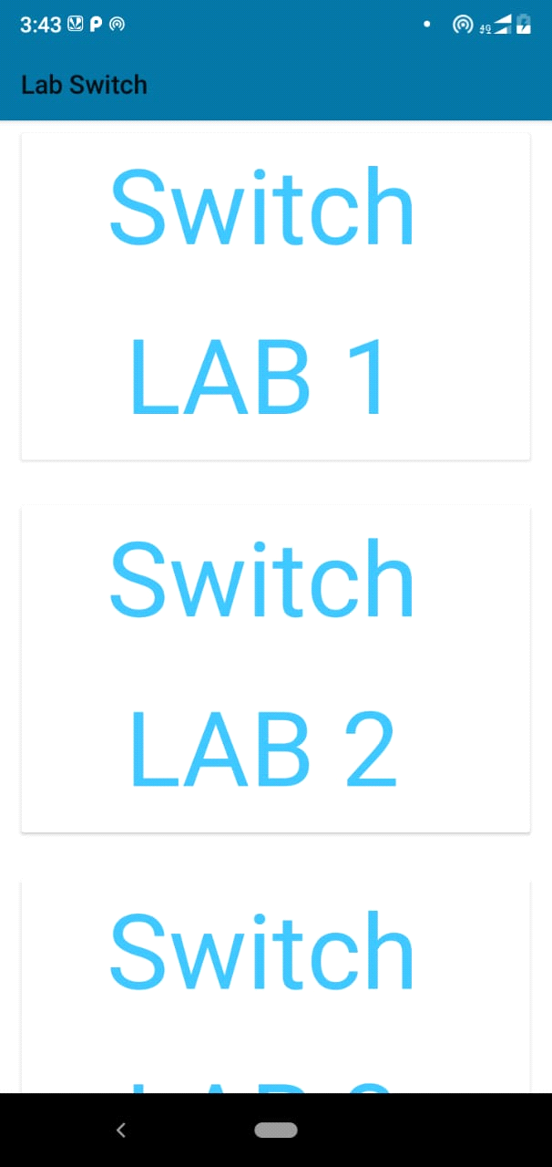

Fig 21.Switch labs Screen

This screen shows the list of scrolling blocks, each containing one lab. A long press on one lab, will result in drop down box containing two options *ON/OFF .* Here, the user will be able to control the electric switches of the corresponding lab.

* **Conclusions/Recommendations**

At the end of this project we can conclude that, this project is very helpful for the lab attendants of an organization. This project will save a lot of time of the lab attendants to do some productive works, rather than wasting time in just shutting down each computer one by one in the labs. This project is very useful and time saving. And in today’s world time is more important than anything else.

How, cool it is to control whole lab, just through the mobile phone and mobile application. Our project can be seen as a revolution in the working culture of labs in the college or other organizations.

Finally it is recommended to use this application as much as possible, because it is easy to use and time saving. But, just keep in mind that this application works only when connected to the target network.

* **References**

Most of the project was done originally by our team, as the idea as raw and totally new. Here, we can refer to the websites and books which were used to gather information about the existing system and to learn the technologies that are used in the implementation of the project.

Android :

javatpoint(https://in.search.yahoo.com/search?fr=mcafee&type=E211IN0G0&p=javatpoint+android+tutorial), tutorials point (<https://www.tutorialspoint.com/android/index.htm>), Android developers(https://developer.android.com/courses/).

* **Appendix**
* **Centralized server:** A type of [network](https://www.webopedia.com/TERM/N/network.html) where all users connect to a central server, which is the acting agent for all communications. This server would store both the communications and the user account information. Most public [instant messaging](https://www.webopedia.com/TERM/I/instant_messaging.html) [platforms](https://www.webopedia.com/TERM/P/platform.html) use a centralized network. Also called *centralized server-structure*.
* **Receiver** file:All the target computers, must contain a receiver file, which is created by us in .C .This receiver file is written in C language. This file is made for reading the commands sent from the master computer. This file reads the commands and commands to target computer to accordingly.
* **Sender File:** Master computer, must contain sender file, which is created by us. This file is written in C language. This file is made to send the signals to the receiver/target computers. This file receives signals from the mobile phone.